Breaking Down House Price and Construction Costs

Special Studies, March 5, 2010
By Paul Emrath, Ph.D, Vice President for Survey and Housing Policy Research
Economics and Housing Policy
National Association of Home Builders
Report available to the public as a courtesy of HousingEconomics.com
Over the years, NAHB has periodically conducted "construction cost surveys" that collect information from builders on the various components that go into the price of a typical single-family home. NAHB's 2009 construction cost survey shows that costs of construction accounted for nearly three-fifths of the final sales price of the average home, and cost of the finished lot accounted for just over one-fifth. These shares have shifted noticeably since the previous construction cost survey (2007), reflecting in part a change in survey methodology that was undertaken to provide a better, more representative sample of single-family construction across the country.
A distinguishing feature of the NAHB construction cost surveys is the detailed information collected on components of construction costs. Despite the change in survey sample design, the shares of most construction cost components remained relatively stable between 2007 and 2009. Any significant trends were often evident before 2009 and coincident with observable changes in materials prices. For example, although framing and trusses remain the largest individual component of construction costs, the share has declined from over 20 to under 16 percent of total construction costs. This trend was evident before 2009, however, and coincides with a period of generally declining prices for framing lumber. The following sections describe the methodology of the survey and discuss the results in more detail.
The 2009 Cost Survey
NAHB's 2009 construction cost survey was conducted by emailing a questionnaire to a representative sample of 1,000 home builders. The sample was stratified by size of the builder (based on number of starts) and region of the country (the sample being proportional to housing starts in each of the four principal Census regions).
Respondents were asked to provide information about the average home built by their firms during 2009. Usable responses were received from 54 builders. As is usually necessary when conducting a detailed business cost survey, extensive follow-up phone interviews were undertaken in order to verify various cost numbers and minimize item non-response.
The average size of homes built across all 54 builders in the survey was a little over 2,700 square feet, and the average lot size was half an acre. These numbers are not comparable to average home and lot sizes reported in previous NAHB construction cost studies due to a change in survey methodology. Previous construction cost surveys were based on local home builder associations recommending particular builders in selected metro areas to NAHB.
The 2009 survey design was altered with the intent to capture a more nationally representative sample of builders, including builders in non-metropolitan areas who had been previously excluded. Outside of metropolitan areas, land prices tend to be lower and lot sizes tend to be larger. The Census Bureau's data on new residential construction show that average lot size was .36 acre for new homes sold inside metro areas in 2008, compared to .65 for new homes sold outside of metro areas. Readers interested in lot size trends (PDF) should consult this source.
For similar reasons, readers should not rely on NAHB construction cost survey results for trends in new home sizes. A better source is the Census Bureau's "Quarterly Starts by Purpose and Design." These quarterly Census statistics show that the median size of new homes started, which had been running well over 2,200 sq. ft. from 2005 through 2007, declined thereafter and was down to about 2,100 sq. ft. in 2009. [1]
The average price of the new single-family homes in the 2009 construction cost survey was $377,624, with the cost of the finished lot accounting for a little over one-fifth of the price; the cost of construction accounting for nearly three-fifths; and the remainder is divided among the costs of financing construction, selling the home, overhead and profit (Table 1).
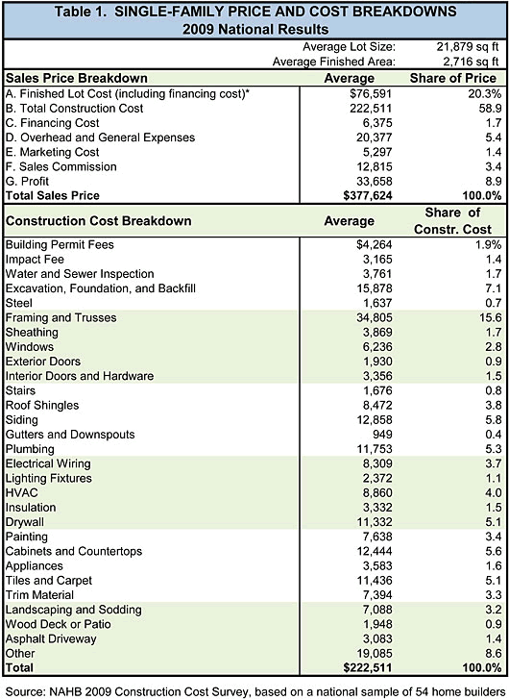
Construction costs include only costs paid by the builder. Any costs paid by the developer are subsumed within the cost of the finished lot.
The sales price breakdown in Table 1 is generally consistent with the Builders' Cost of Doing Business (CODB) surveys sponsored by NAHB's Business Management Department [4] - although the two surveys are not perfectly comparable, because the CODB is based on income statements for a firm, rather than price of an average house. In the recent past, CODB studies have been published in even-numbered years.
In Table 1, lot and construction costs together account for just under 80 percent of the finished house price. This is similar to the cost of sales shares reported in CODB from the mid-1980s through 2006. The 8.9 percent profit in Table 1 is likewise similar to the combination of net income before taxes and owner compensation reported in CODB in most years. The sum of owner compensation and net income in CODB averaged 9.1 percent of firms' total sales from 1993 (when CODB began collecting separate data on owner compensation) through 2006.
In 2008, CODB reported a record high share for cost of sales and a record low—in fact, negative—net income before taxes. In 2008, the months' supply of new unsold homes on the market was escalating to historic highs for many firms. [5] Firm-level costs associated with the unintended build up of an unsold inventory would tend to be captured in firm-level income data, but probably not in the price breakdown of an average home reported in the construction cost survey.
Table 1 also shows how the average $222,511 cost of construction for the respondents' average new home breaks down. As mentioned in the introduction, framing and trusses account for the largest share of construction costs (15.6 percent), followed by excavation, foundation, and backfill work (7.1 percent). Siding, plumbing, drywall, cabinets and countertops, and tiles and carpet account for between 5 and 6 percent each.
Cost Shares Over Time
For reference, Table 2 shows the basic sales price breakdown for a single-family house from all construction cost surveys conducted by NAHB since 1995. (Table 2)
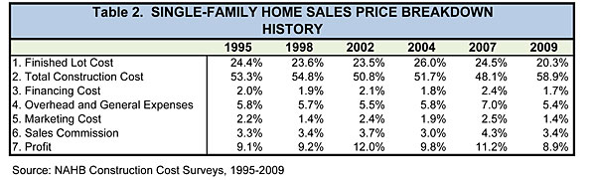
Readers should bear the change in sample design in mind when comparing 2009 shares to previous years. In addition to capturing homes built outside of metro areas for the first time, the 2009 construction cost survey also included a relatively high proportion of custom homes (homes built on a lot owned by the customer, who hires a general contractor to perform the construction work), rather than built-for-sale or "spec" homes. Although this may in part be attributable to the 2009 change in sampling technique, Census data also show that the ratio of spec to contractor-built homes has in fact declined recently - from over 6-to-1 in 2004 through 2006 to under 4-to-1 in the later part of 2008 and 2009. In other words, spec homes were hit particularly hard during the latest downturn in the home building industry.
Table 3 shows the detailed construction cost breakdown for surveys conducted since 1998. [6] (Table 3)
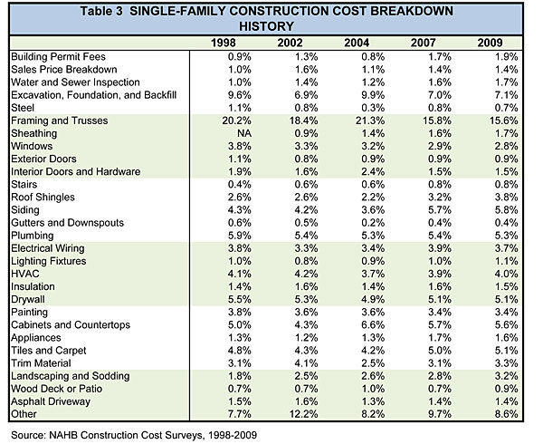
The cost shares in this table appear to be relatively stable across the 2007-2009 divide. Caution is nevertheless advisable when comparing 2009 to previous years, due to the change in survey sample design, and it is best to concentrate on trends that were already evident in the data prior to 2009. There are relatively few of these, as many of the cost shares in Table 3 remain nearly constant across the entire table.
Figure 1 shows two components of a single-family home that have declined as a share of construction costs since 1998: framing/trusses and windows. (Figure 1)
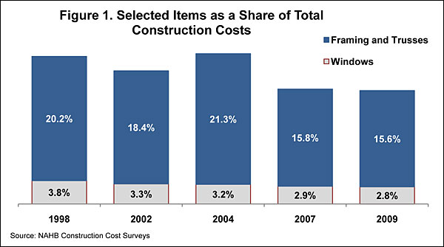
The cost shares for these two items have declined more or less steadily, although the share for framing and trusses jumped upward temporarily in 2004. Some of the cost-share changes coincide with known movements in the prices of key building materials. For example, data from Random Lengths of Eugene, Oregon show a strong spike in prices for framing lumber in 2004, followed by a period during which lumber prices generally declined.[7] This is consistent with the cost-share pattern for framing and trusses in Figure 1.
Figure 2 shows two components of a home that have meanwhile been increasing as a share of total construction costs: siding and roof shingles. (Figure 2)
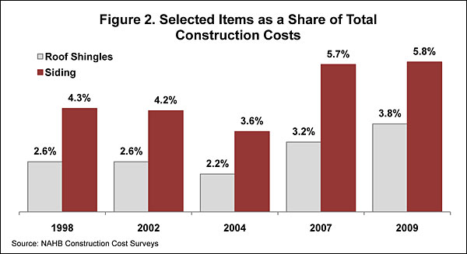
The rising share of costs for roof shingles may be due largely to changes in asphalt prices. The Builder Practices Survey [8] conducted annually by the NAHB Research Center indicates that asphalt continues to hold a dominant share of roughly 80 percent of the market for single-family detached roofing materials. The Producer Price Indices produced by the U.S. Bureau of Economic Analysis show prices for asphalt shingles and coating materials increasing by more than 10 percent a year in 2005 and 2006, and by more than 18 percent a year in 2008 and 2009.[9] This coincides with the post-2004 cost-share increases for roof shingles shown in Figure 2.
The Builder Practices Survey suggests that the rising cost-share for siding may be the result of a shift toward more expensive materials. The survey indicates that, since 2002, brick has steadily increased its market share and replaced vinyl as the siding material most commonly used on single-family detached homes.
Figure 3 shows several components that have also increased as a share of construction costs, but are not a part of the physical structure: landscaping and two categories of fees. (Figure 3)
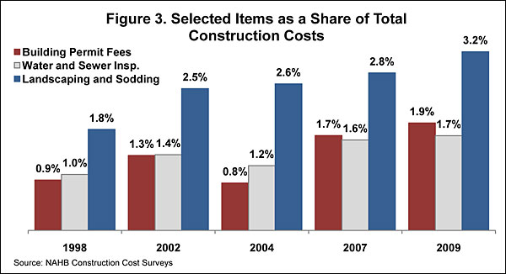
All of the fees in Table 1, Table 3, and Figure 3 represent fees paid by the builder and exclude any that might be paid by the developer (which would be embodied in the finished lot cost). So the increasing costs shares for fees could reflect an actual increase in fees relative to other construction costs, but it may also be that collection of the fees is being deferred to the point that they are being paid more often by builders than developers. To the extent that local governments must collect construction-related fees, NAHB has long argued that it is better to collect them as late in the development/construction/sales process as possible, in order to avoid higher financing and other costs that would typically be passed on to the ultimate home buyer.
For more information about this item, please contact: Robert Dietz at 800-368-5242 x8285 (rdietz@nahb.org)
Resources:
Tables and Figures
See more Special Studies
Footnotes:
[1] The number for 2009 is preliminary and likely to be revised. The Census Bureau also provides a series on the median size of new homes completed, which drops to under 2,200 sq. ft. later than the series based on starts.
[2] The latest edition of the Cost of Doing Business study is available through BuilderBooks.com
[3] See the Census Bureau's series on "Houses Sold and For Sale by Stage of Construction and Median Number of Months on Sales Market" (PDF)
[4] An equivalent detailed breakdown from the 1995 Construction Cost Survey is not available.
[5] These Random Length data are compiled by NAHB and included in the 30 tables of housing statistics available to subscribers of HousingEconomics.com
[6] Information about the Builder Practices Survey is available on the "Building Materials Demand Data" section of the NAHB Research Center's website
[7] Producer Price Indices for selected building materials, such as asphalt shingles, are also available to subscribers of HousingEconomics.com.

